Principal Program Modification Stakeholder Follow Up Survey
Description of the Data Tool
A follow-up stakeholder survey was administrator to current in-service principals and superintendents who have collaborations with the University of Akron. The original Survey was administered by the program faculty in 2019 to collect stakeholder data on how to revise the principal program. The survey results were disseminated with program faculty, and partner school administrators in Dean’s advisory Board meeting in 2019 and guided the curriculum change in 2020.
Data Collection Procedures
The Follow-up survey kept the original format of the 2019 survey with both Likert scale questions and open-ended questions. The following screenshot presents how the tool was sent to school administrators via qualtric online survey tool.
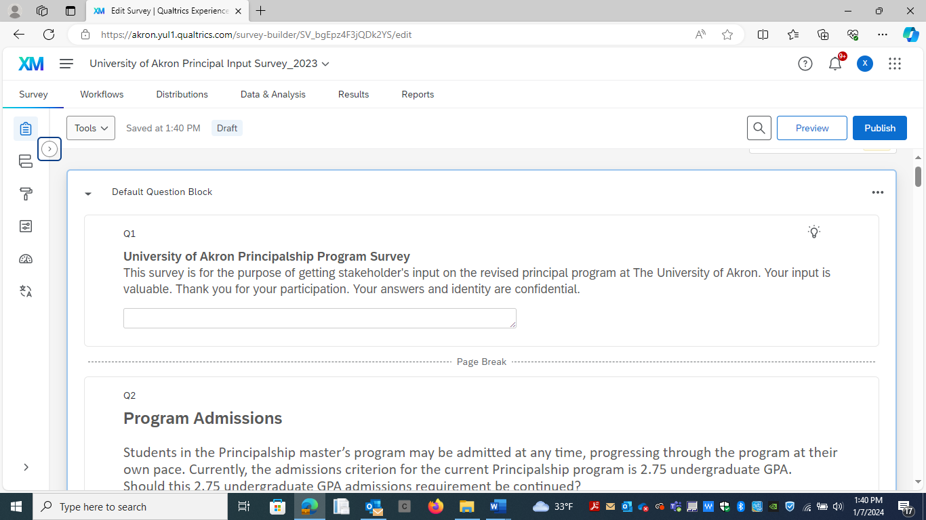
Data Analysis
Nine in-service school leaders responded to the survey. Among them, 5 were school principals, 3 were superintendents, and 1 was curriculum director.
- GPA Requirement: 78% of the respondents support the 2.75 minimum GPA requirement, and 22% felt that if a candidate is mature and have a passion, a minimum GPA 2.75 GPA may not be that important.
- Course delivery: 100% responded to having hybrid delivery mode to accommodate schedule and quality of learning in a face-to-face learning environment. They felt the current delivery mode serves the needs of the in-service teachers for leadership professional development.
- Program Content: About 90% of the school leaders rated the course content to be extremely relevant to school leaders. 100% of school leaders rated “Organizational leadership” and “Supervision of Instruction” courses to be extremely relevant. Open-ended responses further explained that school law and instruction supervision are very important curriculum for school leaders to learn.
Two school leaders (22%) rated “Management of Physical Resources” less relevant. Faculty will need to discuss this topic for further actions in the Spring 2024 Faculty Data Review. This topic may be presented to the LJFF School Advisory board meeting for their input and suggestions.
The in-service school leaders also responded very positively to our approach of inviting experienced in-service principals or superintendents to teach the courses.

Clinical Experiences: There are very positive responses on the current practice of clinical experience related to timely supervision on site, the length and depth of internship activities and CFA and internship interactions.

Data Results Presentation

- Admission Requirement
- Should Undergraduate GPA 2.75 required to be admitted to the Principal Program.

 | Frequency | %
Yes | 7 | 78
No | 2 | 22
Comments:
- I personally believe that if someone matures a little late and is committed to the program there should not be a minimum GPA requirement.
- It needs to be higher. As a leader, you need to hold yourself to a higher standard.
- It should not be any lower than a 2.75, if anything, it could be higher.

- Applicants who wish to pursue the Ohio Principal Licensure must also hold a valid Ohio teaching license for a minimum of two years. Is this requirement to be continued?
 | Frequency | %
Yes | 9 | 100
No | 0 | 0
Comments:
- I do not think that a person should be able to enter and pursue Principal or Administrative licensure until they have held a teaching position for more than 2 years, not just a teaching license for 2 years. One is not equipped to fully support staff and students in a principal role, until they have successfully maintained the responsibilities of a certified teacher for 2+ years. Even after 2 years in a classroom, most are not prepared and ready to take on the role of administrator.
- I would put a clause for out of state experience to be exempted.
- Should be longer. In order to be an effective principal, you have to be it the classroom...period. Two years in a classroom means you had one foot out the door in Year 1 before leaving. Min should be 3 years.
- Two years as a teacher is a short amount of time before going into administration, but two is better than none.

- Program Delivery
Please rate the following delivery methods, with 1 being the least preferred, and 5 being most preferred.
 | F % | F % | F % | F % | F %
 | 1 | 2 | 3 | 4 | 5
100% face-to-face classes | 1 (11%) | 1 (11%) | 2 (22%) | 4 (44.4%) | 1 (11%)
100% online program | 2 (22%) | 2 (22%) | 3 (33%) | 2 (22%) | 0 (0.0%)
Hybrid program, e.g., ½ face-to-face classes, ½ online | 0 (0.0%) | 0 (0.0%) | 1 (11%) | 3 (33%) | 5 (55.6%)
Weekend classes | 2 (22%) | 0 (0.0%) | (55.6%) | 2 (22%) | 0 (0.0%)

- Program Content
The principal master's program includes 8 core courses (24credit hours). Please respond to the relevancy of the following courses: 1= least relevant as a principal and 5=most relevant as a school principal.
 | F % | F % | F % | F % | F %
Course Name | 1 | 2 | 3 | 4 | 5
1. Organizational leadership | 0 (0.0%) | 0 (0.0%) | 0 (0.0%) | 1 (11%) | 8 (88.9%)
2. Management of Physical Resources | 0 (0.0%) | 2 (22%) | 2 (22%) | 4 (44.4%) | 1 (11%)
3. Management of Human Resources | 0 (0.0%) | 1 (11%) | 0 (0.0%) | (55.6%) | 3 (33.3%)
4. School Contexts and Community Involvement | 0 (0.0%) | 1 (11%) | 0 (0.0%) | (55.6%) | 3 (33.3%)
5. School Law | 0 (0.0%) | 2 (22%) | 0 (0.0%) | 2 (22%) | (55.6%)
6. School Finance & Economics | 0 (0.0%) | 0 (0.0%) | 3 (33.3%) | 3 (33.3%) | 3 (33.3%)
7. Supervision of Instruction | 0 (0.0%) | 0 (0.0%) | 0 (0.0%) | 0 (0.0%) | 9 (100%)
8. Student Services and Disability Law | 0 (0.0%) | 0 (0.0%) | 0 (0.0%) | 2 (22%) | 7 (77.8%)

Please identify what course work you believe is essential for preservice principal student to learn to be effective school leaders?
- Supervision of instruction. They are the instructional leader of the building. If they don't have good pedagogy, they will not be successful.
- School Law; Student Services and Disability Law (work VERY collaboratively with staff and other admin in order to best support and serve our SWD, as well as maintain compliance);
- Supervision of Instruction (OTES and criteria for supporting staff improvement); Organizational Leadership (climate and culture within the building/community). Yes, they bring relevant experience and knowledge to provide individuals obtaining licensure.
- Principals need to know how to lead. That is where I see the biggest gap. They don't get mission, vision, values. Then secondarily, but essential is they need the law and HR parts of the job along with being an instructional leader.
- Special ed law is a key piece that needs to be mastered
- Supervision of Instruction/Disability Law
- Please consider (1) course work in instructional leadership that includes leading data teams and the Ohio Improvement Process; (2) course work in employee discipline and due process; and (3) course work in employee evaluation. High performing practitioners should be consulted in course development. Asking practitioners to teach courses is a good strategy. Including practitioners as guest speakers in classes is also an important strategy.
- Instructional leader
- Anything associated with being a better instructional leader and building a strong culture of learners both student and adult.

- Internship Experience
A requirement of the internship should | Yes | No
1. provide preservice principals with an opportunity to lead a year-long school improvement program developed with the school. | 9 (100%) | 0 (0.0%)
2. Be that the intern be exposed to broad experiences in building operations. | 9 (100% | 0 (0.0%)
3. Be that the intern be supervised on site by university personnel. | 6 (66.7%) | 3 (33.3%)
4. University personnel who supervise interns should visit the school and observe the intern at least monthly. | 6 (66.7%) | 3 (33.3%)
5. The intern be supervised on site by the Cooperating Field Administrator. | 9 (100% | 0 (0.0%)
6. University personnel should communicate (meet, phone, email) at least monthly with the Cooperating Field Administrator to discuss the progress of the intern. | 7 (77.8%) | 2 (22.2%)
Comments
University personnel who supervise interns should visit the school and observe the intern at least monthly.
- Not sure about monthly. Might be more like quarterly.
- One to start the internship, one to check in, and one to complete is plenty.
We invite in-service principals or superintendents to teach the courses. Do you believe this approach is positive? Please explain.
- Yes. It's always good to hear real world applications/stories.
- Yes, they bring relevant experience and knowledge to provide individuals obtaining licensure.
- Yes, they are the boots on the ground and can prepare students for what they are going to face. You just have to make sure these people are leaders in the field and not someone collecting a paycheck.
- Very positive! Sharing actual situations and the lessons learned blends perfectly with the textbook knowledge.
- Yes. I have asked in the past to help, as a guest speaker OR start teaching classes and have been turned down. I am a successful principal from the area with many years of service which I feel is VERY valuable for students to hear from. All to often, professors leading the classes are far removed from public education which makes it hard to deliver relevant, appropriate content. Again, I am willing to assist and/or teach classes for the education program and principal licensure.
- High performing practitioners should be consulted in course development. Asking practitioners to teach courses is a good strategy. Including practitioners as guest speakers in classes is also an important strategy.
- Yes, as long as it is not in super doses. I think people in the trenches carry a lot of information.
- Yes, experience is key
- Yes, I suspect the experience from the field that is shared is valuable.
Please identify experiences that you believe are essential for preservice principals to engage in while doing their internships.
· They just need to see all parts of the principalship.
· Preservice principals should engage in as many leadership activities as possible to experience a full range of real-life/day-to-day situations they may face as a future leader/principal. Ex: ETR/IEP meetings, Parent/Community Engagements; Discipline hearings/meetings; Legal updates; Building Leadership & District Leadership meetings, etc.
· They need to see how the evaluation process should go when done well. They need to learn how to manage people. I see too many leaders avoid tough conversations. Interns need to be taught by people who can have tough conversations. Interns need to know how to hire staff and mentor them. They need to learn how to see an initiative from start to finish.
· Leading a program from start to finish, opportunities to speak in front of parents and community members.
· If your student approaches their principal of choice to work with, they trust that principal is effective. The principal should in turn provide a variety of opportunities for that student to experience. They trust that principal to prepare them appropriately. Examples include IEP meetings, tough parent phone calls, scheduling meetings, discipline/hearings, observations of teachers, etc...
· Leadership in instruction with data to support
· Anything to do with being an instructional leader that nurtures learning environments that support student and staff growth. ex. classroom observations, PLCs, development of a vision or at least educational philosophy which will help principals to anchor their decisions to, etc.

